Student’s name | …………………………………………………….…… | Grade | 4
Subject | Computer | Week No. | 4
Lesson Title | Network Connections | Unit
Worksheet No. ( 4 )

write the correct name of each part.
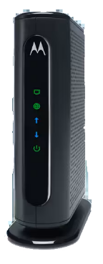
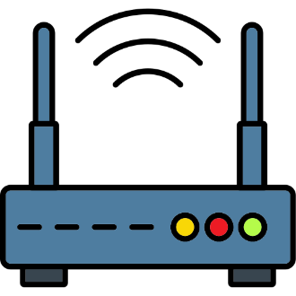

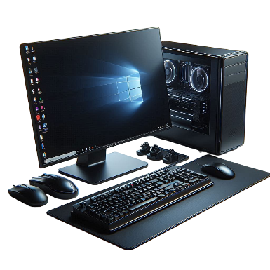
Good Luck

Router
Modems
Laptop
CPU

